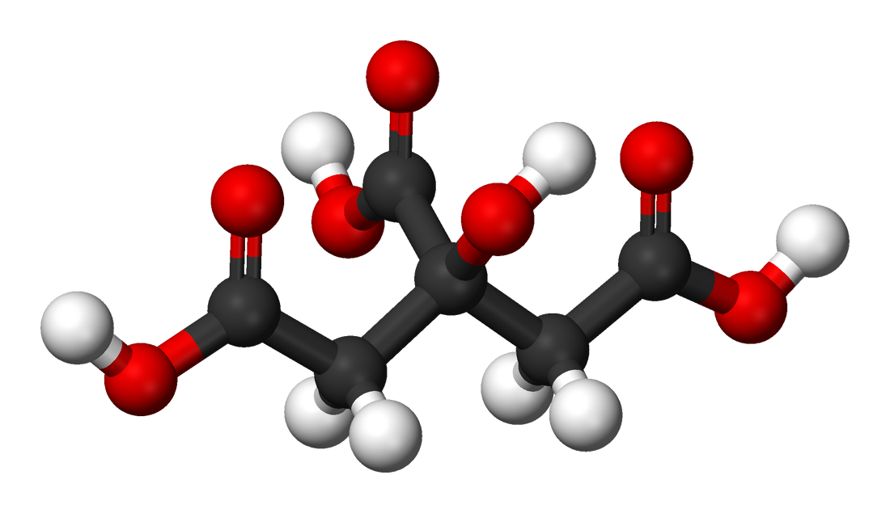
Course Syllabus

Chemistry 31B, Winter 2020: Chemical Principles II: Reactivity & Energetics
Professors Cegelski & Cox

Course Overview:
The science of chemistry evolves through a process of observation, hypothesis, and experimentation. This course is structured to develop your skills to participate in this process while building your understanding of how chemical phenomena shape our world.

Course Objectives: Develop your ability to analyze and solve chemical problems through improved critical thinking.
- Improve your ability to use conceptual models to qualitatively explain a wide range of chemical phenomena and to make quantitative estimations focusing on the following areas:
  - Kinetics: Determine what forces influence the rate of a chemical reaction.
  - Equilibria: Determine the direction of a reaction and the changes in concentration that will occur as a reaction comes to equilibrium.
  - Thermodynamics: Predict whether a reaction is likely to be spontaneous and describe the relationship between free energy, temperature, and equilibrium constants.
  - Electrochemistry: Identify redox reactions and calculate their reduction potentials based on their conditions. Describe how to build a voltaic cell.
- Be prepared to study how structure influences chemical reactivity and equilibria in Chem 33.

General Information

For most questions you will get the fastest and most accurate response by posting to Piazza rather than emailing. Please post on Piazza first for both logistical (ex: due dates, office hours, exam time and place, and troubleshooting MC or technology problem) and content questions (homework help and question clarification). Otherwise use dory@stanford.edu.

Instructors: Professor Lynette Cegelski Dr. Charlie Cox
cegelski@stanford.edu ctcox@stanford.edu
phone: 650-725-3527 phone: 650-485-1041
office: Keck 351 office: STLC 205
OH: Thursday 2:30-4 PM (Keck 351) OH: Wednesday 6 – 7:30 (STLC 114)
Problem Solving Session

Head TA : Dory DeWeese
dory@stanford.edu

Please contact Dory with questions regarding course logistics and accommodations.

Additional Dr. Kevin Sibucao (ksibucao@stanford.edu). Dr. Sibucao will hold Monday problem solving
Support: sessions from 6:00 – 7:30 pm in STLC 114. Dr. Sibucao is also teaching 31BC this quarter.
Please email him directly with questions.

Office hours Office hours are available to further clarify lecture concepts or assist students in developing an approach towards tackling chemistry problems. Students are highly encouraged to rework misunderstood problems from returned exams and Mastering Chemistry and discuss them during office hours.

TA OHs: Sun 6-9 pm STLC 115 MWF 12:30-1:30 pm STLC 105
Tue 7-10 pm STLC 115 MW 7:30-9 :00 pm STLC 115
Thu 7-10 pm STLC 115 (after exams 7-8 :30)

Professor OHs: Thu 2:30-4 PM Keck 351 (Cegelski)
Wed 6 – 7:20 PM Sapp 114 (Cox)

Course Structure
Lectures: Lecture attendance is compulsory. The same lecture is given at each of the three times; attend the section in which you enrolled on Axess.
Times: MWF 11:30am - 12:20pm STLC 114
or 1:30pm – 2:20pm STLC 114

Lab Safety: To minimize risk associated with working in a chemical lab, all students must complete the online safety training course. If you have already completed the Safety training for Chem31A in 2018, then you do not need to retake the online course until next academic year. We advise you to review the safety information posted on Canvas. If for any reason a student has not completed the safety training from last quarter, they must complete the Safety Training module on Canvas in the first week of class.

PPE: Students entering the teaching laboratories must wear appropriate Personal Protective Equipment (PPE), which includes laboratory glasses and a laboratory coat, in addition to appropriate street clothes (long pants, solid shoes that cover your entire foot). If you need a replacement coat or glasses from Chem31A (or if you do not have a coat or glasses for any other reason), you can purchase PPE in STLC during the first week. An announcement will be made in class regarding the location. A $50 charge will appear on your university bill to cover the cost of the Lab coat + glasses if you purchase a replacement. Students must wear their glasses and lab coat during section at all times!

Please also note, there will be a separate charge of $55 for laboratory supplies that appears on your student bill each quarter. This is to cover the cost of chemicals, lab equipment, and other supplies used by your lab each quarter.

Problem Dr. Sibucao and Dr. Cox will hold problem solving sessions on Monday and Wednesday
Solving: from 6:00 – 7:30 pm in STLC 114. The answers will be posted on Friday after the sessions.

Web Sites: There are two primary websites associated with the course:
- http://canvas.stanford.edu - After registering for Chem 31B on Axess you will have access to the full Chem 31B Canvas website, where you will find course materials, course announcements, your section assignment and your scores on graded work. This is also where you will access “Mastering Chemistry”, where you will complete and turn in problem sets for the course. For “Mastering Chemistry” registration instructions, see the document “Stanford Mastering Chemistry Instructions” which can be found in the “Files” section of the canvas site in the “General Course Information” folder.
- https://piazza.com/stanford/winter2019/31b/home - All course questions should be directed to Piazza.com. This website will allow you to ask and answer questions for the course in a wiki format, so that all students can benefit from the answers! Piazza can also be accessed through our Canvas site.

Required Items – NOTE these are the same as Chem31A so you should NOT need to purchase anything new!

Text: Tro, “Principles of Chemistry: A Molecular Approach” 4th Edition

Problem Set: All Chem 31B students must have a valid license for the web-based
Software “Mastering Chemistry” program (based on our Tro textbook).** (this is the same as your
License license from last quarter).

All materials are the same as 31A. Detailed instructions on purchasing and registering a MasteringChemistry access code and/or e-text are still available as a handout on the Chem 31B Canvas site.

i-Clicker All Chem 31B students must have a hand-held i-Clicker2 (available at the Stanford Bookstore) or the original i-Clicker to answer in-class questions drawn from assigned readings. Questions on the lecture material will also be posed during lecture to provide immediate feedback as to your understanding of the current material. You may only click and respond with your own personal i-Clicker. Before lecture on Monday (Jan 6, 2020) register your i-Clicker in Canvas.

GRADING
1. Course Engagement: Course participation points can be accumulated through any combination of clicker questions, and problem sets to a maximum of 130 pts. Details of course engagement components are below:

- Lecture Participation: Clicker questions: (at least 60 pts. available)
In-lecture clicker questions will be posed throughout the quarter, related to the assigned reading, Pre-Lecture Problems, section, and lecture discussion. Each correct answer is worth 1 pt.
- Pre-Lecture Problems: (84 pts possible)
The night before each lecture, you must complete your Pre-Lecture Problems (PLP) through the web-based MasteringChemistry system by 11:59pm. The assignments on Tuesday and Thursday are valued at 2 points each. The Sunday assignments will be longer and will be valued at 5 points. You are allowed and encouraged to work on the problems with others, but you must compose your final answers to each problem set on your own.

2. Labs: Each week there is a lab that will engage with the material discussed in lecture through prelab assignments, attendance and participation, and write-ups. You can count a maximum of 120 points.

Because lab skills and safety build upon each course in the sequence, it is expected that students will attend at least 7 out of 10 labs. Failure to attend at least 70% of the labs will result in a drop of one full letter grade for the student’s final course score.

Prelab: (3 pts. each; 30 pts available):
Before each lab, students are expected to read the pre-lab assignment and answer any questions posed. A typed PDF must be uploaded to Canvas by 11:59 pm the Sunday BEFORE lab.
Section: Attendance and Safety Adherence: (5 pts. per week; 50 pts available)
Because sections are based on participation in groups and will begin with important safety information, it is critical to arrive on time. Students who are more than 5 minutes late will forfeit their participation points, as will students who are dismissed from lab for not adhering to safety policies, or failing to help clean up after the experiment.
Lab Write Ups: (15 pts. each, 45 pts. available)
There will be three short reports (1-3 pages) on activities in section. Feel free to discuss section with others, but the actual report must be solely of your own composition. Reports must be submitted as a PDF to Canvas at midnight the Saturday directly following lab.

3. Midterm exams: There are two midterm exams on Wednesday evenings held on Jan. 29th and Feb. 26th from 6-7:15pm. Exams will take place in Hewlett 200 and Hewlett 201.
4. Final exam: The final exam will be given only on Wednesday, March 18, from 12:15 – 3:15 pm. Make sure that you are available for this time before enrolling.

Exceptions: Chemistry 31B is a large, quickly moving class with nearly 300 students. Special exceptions that are accommodated include documented disabilities, University sanctioned absences and extraordinary life events. Such accommodations should be requested from the Head TA at least one week in advance email dory@stanford.edu. The teaching team has decided to limit incidental accommodations (e.g. late problem set, late arrival at sections or absences due to travel/illness, exam conflicts) so that we can focus on our educational mission in the course. The grading scheme is constructed with deliberate flexibility to allow for unexpected illnesses or travel. Our best advice is to be prompt in arriving at lectures, sections and exams, be prompt in delivering PLPs, and to prepare for and participate in lab section.

Grade: Your grade is determined according to the total number of points you have accumulated for course engagement & laboratory, mid-term exams, and final exam. Two options will be used to compute grades, and students will automatically be given the better of the two options. The first option is course engagement & laboratory (250 pts), mid-term exams (400 pts), and final exam (350 pts). Alternatively, the second option will weigh the final more if beneficial for students. The second option is course engagement & laboratory (250 pts), mid-term exams (200 pts), and final exam (550 pts). Both options give 1000 possible points with grades being computed using the following distribution.

≥950 A+ ≥800 B+ ≥650 C ≥500 D+ <400 NP
≥900 A ≥750 B ≥600 C+ ≥450 D ≥550 CR
≥850 A- ≥700 B- ≥550 C- ≥400 D- <550 NC

Return of The most recently graded lab write-up will be posted on Canvas by your next lab section.
Work: Problem Sets are automatically graded and solutions shown on MasteringChemistry.
All exams are returned via Gradescope by the Friday following the exam.

Regrades: Regrade requests must be submitted via Gradescope no later than 2:30pm on the Wednesday following the exam. When an exam is submitted for a regrade, the entire exam may be reevaluated, with the possibility of a net gain or loss of points.

Dept. Policy It is the policy of the Department of Chemistry that exams and quizzes are not given earlier than the scheduled time for the whole class. Similarly, problem sets and other instructor-defined assignments should not be released to any student earlier than they are released to the class as a whole.

Students Students who may need an academic accommodation based on the impact of a disability must
with initiate the request with the Office of Accessible Education (OAE). Professional staff will
Documented evaluate the request with required documentation, recommend reasonable accommodations,
Disabilities and prepare an Accommodation Letter for faculty dated in the current quarter in which the request is being made. Students should contact OAE (http://studentaffairs.stanford.edu/oae) as soon as possible since timely notice is needed to coordinate accommodations. In addition, please inform the Head TA as soon as possible, at least one week in advance of the first exam.

As part of our ongoing efforts to make this course an even better experience for students, our teaching team continually conducts research to improve our teaching methods. In this course, new teaching methods may be used and various aspects of student performance analyzed on an ongoing basis. Information about you and your performance in this course will be held strictly confidential. If you would like to opt out of participating in any new teaching methods or having your performance analyzed as part of this research, you may do so without penalty. For more information please contact Dr. Charlie Cox (ctcox@stanford.edu).

Larger Course Expectations:
What you can expect from the teaching team:
We are here to guide your learning and will challenge you to actively engage in the learning process through class activities, assignments, and more. We will strive for an inclusive and collaborative classroom and welcome any suggestions for improvement. We will do our best to give you the tools, feedback, and support to succeed, so let us know if the teaching team can do to aid in your learning. Learning is a never-ending process, so we hope to motivate you to seek out more information on topics we don’t have time to cover or think about how chemistry can apply to other processes we don’t discuss. We highly encourage everyone to visit during our office hours or the teaching assistants in office hours, even if you don’t feel that you have questions. We are here to aid in your learning process!

What we expect from you:
We will expect you to take an active role in your learning by coming to class prepared and being ready to share your ideas and collaborate with your classmates. Each member of this class has different ideas and perspectives that will enrich the experience for everyone else, so we ask you to be respectful and thoughtful in your interactions. To get the most out of the class, you should be prepared to share your ideas, ask questions, listen actively and collaborate effectively during small group work. Never hesitate to email us, stop by our office hours, or set up a meeting. This class should challenge you, but we believe everyone has the ability to succeed with some effort.

Respect for diversity statement:
It is our intent that students from all diverse backgrounds and perspectives be well served by this course, that students’ learning needs be addressed both in and out of class, and that the diversity that students bring to this class be viewed as a resource, strength and benefit. It is our intent to present materials and activities that are respectful of diversity, which may include but not limited to: gender, sexuality, disability, age, socioeconomic status, ethnicity, race, religion, political affiliation and culture.. Your suggestions are encouraged and appreciated. Please let us know ways to improve the effectiveness of the course for you personally or for other students or student groups. In addition, if any of our class meetings conflict with your religious events, please let the head teaching assistant know so that we can make arrangements for you.

All people have the right to be addressed and referred to in accordance with their personal identity. We will do our best to address and refer to all students accordingly and support classmates in doing so as well.

