Introduction to Urban and Regional Planning
Stanford University Program on Urban Studies
Instructor: Marisa Raya
Wednesdays 3:30pm-6:25pm

Course Description

This is a practice-oriented course that provides an overview of multiple disciplines within the field of Urban and Regional Planning. The course covers the basic tools and techniques of planning as well as the practice of recognizing, reading and working with diverse communities and places. The goal is to empower students to play a role in transforming their environments through understanding the professions and processes involved.

We will examine Planning from a wide range of perspectives, from local government policymaking to grassroots organizing, through power dynamics, economics, and as a medium for social and cultural negotiation. In addition to concepts, theories, and tools, students will learn how to identify issues in communities and landscapes and address them through planning processes. Students will be expected to think and write critically about urban landscapes both familiar and new, and lead facilitated discussion and planning exercises.

Syllabus

January 11 : Democracy, Planning and Governance

Readings:
1. Dolores Hayden, “Urban Landscape History: The Sense of Place and the Politics of Space.”
2. Jacob Riis, How the Other Half Lives- Full text available at http://tenant.net/Community/Riis/contents.html (skim)
3. Jane Jacobs, The Death and Life of Great American Cities Part 1, Pgs 1-88 (“The uses of sidewalks;” Part 2, pgs. 145-177, “The generators of diversity” and “The need for primary mixed uses.”

YouTube Videos: Public Workshops for the Bay Area Sustainable Communities Strategy

Assignment: Pick one movie from the following article or the comments section: http://www.planetizen.com/node/141 Describe its view of urbanism and themes as you think they relate to planning.

January 18: What is a Plan?

Readings:
1. Redwood City Downtown Precise Plan
2. North Fair Oaks Community Plan
3. Mission Street Case Study, Eastern Neighborhoods Plan, San Francisco

Assignment: Find a Neighborhood, Specific or General Plan online from a place you have lived and prepare a short presentation (4 slides) on it that addresses the following:
- Who lives and works in this community? If the demographics are not in the planning document, use www.census.gov to create a community profile that includes population size, race, age, and incomes.
- How does this plan reflect the character and values of that place?
- Is there anything you would have included that is not in the plan? What might be some of the limits of the planning process?

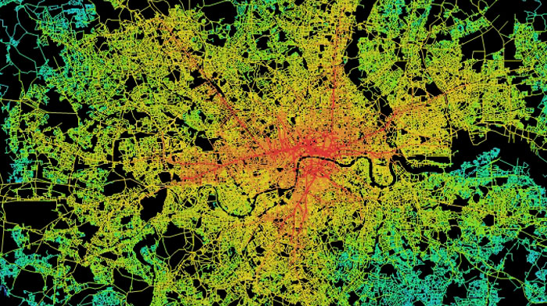
Jan 25: Space as a Medium for Social Relations

Readings:
1. Henri LeFebvre, The Production of Space (selection)
2. Bill Hillier, Space is the Machine
3. Marshall Berman, All that is Solid Melts Into Air (selection)
4. Katherine McKittrick, “Freedom is a Secret,” from Black Geographies

Assignment: Describe either LeFebvre’s or Hiller’s theory of space as a social medium.

Fig. 1: Space Syntax Map of London, Space is the Machine

Feb 1: Balancing Public Benefits and the Private Market: Zoning and Value Creation

Readings: Nico Calavita, Inclusionary Housing in an International Perspective: Affordable Housing, Social Inclusion, and Land Value Recapture. (Selection.)
Partnership for Working Families, Community Benefits Agreements in Effect
Abbot, Detwiler, et al., Exactions and Impact Fees in California (Introduction.)

Assignment: Create a development proposal in response to the provided RFP (“Request for Proposals”) for the rehabilitation of a historic building near downtown Oakland. In your proposal, indicate the sources of revenue for the rehabilitation and maintenance of the building.

February 8: Part 1. Transportation and Parking

Readings:
1. Allen Jacobs, Great Streets
2. Donald Shoup, The High Cost of Free Parking (Selection)
- Plan Bay Area, especially Chapter 4, “Investments”

Part 2. Housing

Reading: 1. East Bay Housing Organizations, Affordable Housing Handbook
- Kim-Mai Cutler, “How Burrowing Owls Lead to Vomiting Anarchists, or SF’s Housing Crisis Explained,” TechCrunch
- Nicole Hannah-Jones, “Living Apart: How the Government Betrayed a Landmark Civil Rights Law.” ProPublica

You may choose any one of the follow three assignments:

Assignment: 1. Going back to the community you discussed in Week 2, describe the types of housing existing and permitted in this location. What is the relationship between the residential zoning and the qualities of the place?

Assignment 2: Locate and evaluate a neighborhood, city or regional transportation plan.

OR

Assignment 3: Spend the weekend without a car and describe the experience from a planning perspective. Who else did you see on your trips? What facilities and infrastructure made them easier or more difficult?

Extra Credit (5 points): In preparation for our next class, bring in one example of an environmentally or socially restorative design.

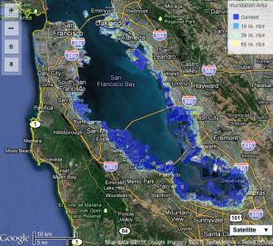
February 15: Part 1. Environmental Services and Protection, Land Conservation and Sustainability

Part 2: Planning for Crises and Resilience

Readings: 1. Mike Davis, Ecology of Fear
- 2010 Urban Water Management Plan for the City and County of San Francisco (skim)
- Ann Riley and Luna Leopold, Restoring Streams in Cities
Google Maps image of the Bay Area from Cal-Adapt’s online interactive sea level rise tool.

Assignment: Sign up for office hours. Based on consultation with the instructor, choose a planning-related special topic and write a proposal for your final paper.

February 22: No class - Make-up class will be the optional field trip on March 4th

March 1: Cities as Economic Engines: Economic Development and Income Inequality
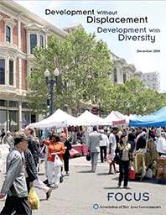
Readings:
1.Edward Glaeser, Triumph of the City (Selection.)
2. Richard Florida, Rise of the Creative Class (Selection.)
3. Neil Smith, The Revanchist City. (Selection.)
4. Leah Platt Boustan, et al., "The Effect of Rising Income Inequality on Taxation and Public Expenditures: Evidence from US Municipalities and School Districts, 1970-2000."
5. J.Philip Thompson, Social Capital and Poor Communities.
6. Marisa Raya, et al., Development without Displacement/Development with Diversity

Assignment: In preparation for next week’s class, bring in an image from a place that you consider to be beautiful. Be prepared to describe what features you think contribute to this quality.

March 4 (Saturday): Field Trip. Meet at Lake Merritt BART Station, Oakland, CA. We will have a walking tour of the area, visit the site from your February 1 assignment, and discuss local development proposals.

March 8: Part 1. Urban Design

Readings: Roberto Bedoya, “Spatial Justice: Rasquachification, Race and the City”
Charles Montgomery, Happy City: Transforming Our Lives through Urban Design (Selection)
William H. Whyte, City (Selection)

Assignment: Final Paper and Oral Presentation

March 15: Part 1. Planning Technologies: Urban Simulations, Land Use Modeling, and Demographic and Economic Forecasting

Fig. 3 Stamen Design analysis of Trees & Crime in San Francisco

Reading: Shaw, Emily. “Civic Wants, Civic Needs, Civic Tech”

Part 2. Oral Presentations. Final Paper due.

Course Grading

Students will complete a brief assignment each week designed to test their understanding of the topic area covered in class. These weekly assignments collectively generate 50% of the course grade. The final paper, which is on a planning subject chosen by the student, is worth 25%. Since the Planning practice is driven by public communication and discussion, the final 25% is based on in-class course participation.

Teacher Bio

Marisa Raya is a former Regional Planner with the Association of Bay Area Governments, where she helped to create Plan Bay Area, the Bay Area’s first long-range plan integrating land use and transportation. She has worked on both regional and local public planning efforts for over a dozen years in the San Francisco Bay Area and Portland, Oregon metropolitan regions, as well as on grassroots campaigns related to land use and community development in Chiapas, Mexico, Portland, Oregon and Oakland, California. She created the Planners Network Disorientation Guide, a planning primer for incoming graduate students. Currently, she works for the City of Oakland in the Special Projects division of the Economic and Workforce Development Department.

Prior to working as a planner, Ms. Raya helped to create the Program on Human Rights and Justice at the Massachusetts Institute of Technology, an interdisciplinary program that promotes a human rights-based approach to international development. She has a Masters in Infrastructure and Spatial Planning from the Royal Institute of Technology in Stockholm, Sweden, a BA in Anthropology from Columbia University, and a certificate in Facilitation and Conflict Resolution from Columbia Teachers College. Having previously published work on gentrification and displacement, her primary interests continue to be the promotion of socially and economically inclusive development as well as environmental and social restoration.

